**Visvesvaraya Technological University**

# Belagavi, Karnataka-590 018



**A**

**PROJECT REPORT**

**ON**

*“HOSTEL MANAGEMENT SYSTEM”*

*Submitted in partial fulfillment of the requirements for the* ***DBMS Laboratory with Mini Project (15CSL58)***

*course of 5thsemester*

**BACHELOR OF ENGINEERING**

**IN**

**COMPUTER SCIENCE AND ENGINEERING**

**Submitted by,**

**SUSHMITHA BHAT N S VARSHA RANI**

**1JS15CS106 1JS15CS114**

##### **Under the guidance of**

###### **Dr. Sneha Y.S**

Associate Professor, Dept of CSE,

JSSATE, Bengaluru



**JSS ACADEMY OF TECHNICAL EDUCATION, BENGALURU**

**Department of Computer Science and Engineering**

**2017-201****8**

**JSS MAHAVIDYAPEETHA, MYSURU**

**JSS Academy of Technical Education**

JSS Campus, Uttarahalli Kengeri Main Road, Bengaluru - 560060

**Department of Computer Science and Engineering**



**CERTIFICATE**

This is to certify that the project work entitled **“HOSTEL MANAGEMENT SYSTEM”** is a bonafied work carried out by **Ms**. **SUSHMITHA BHAT N S (1JS15CS106)** and **Ms. VARSHA RANI (1JS15CS114)** in partial fulfillment for the DBMS Laboratory with Mini Project (15CSL58) of 5thsemester **Bachelor of Engineering** in **Computer Science and Engineering** of the **Visvesvaraya Technological University, Belgaum** during the academic year 2017-2018. It is certified that all corrections and suggestions indicated for Internal Assessment have been incorporated in the report deposited in the department library. The project report has been approved as it satisfies the academic requirements in respect of project work prescribed for the said degree.

## Mrs. Savita S Dr. Sneha Y.S Dr. Prabhudev Jagadeesh

## Asst Professor, Dept of CSE Associate Professor, Dept of CSE Professor & Head, Dept. of CSE

## 

#### Name of the Examiners Signature with Date

**1)…………………………… ………………………**

**2)…………………………… ………………………**

**ACKNOWLEDGEMENTS**

We express my humble pranamas to his holiness **Jagadguru Sri Sri Sri Shivarathri Deshikendra Mahaswamiji** who has showered their blessings on us for framing our career successfully.

The completion of any project involves the efforts of many people. We have been lucky enough to have received a lot of help and support from all quarters during the making of this project, so with gratitude, we take this opportunity to acknowledge all those whose guidance and encouragement helped us emerge successful.

We are thankful to the resourceful guidance, timely assistance and graceful gesture of our guide **Dr. Sneha Y.S,** Associate Professor, Department of Computer Science and Engineering, who has helped us in every aspect of our project work.

We are also indebted to **Dr Prabhudev Jagadeesh,** Head of Department of Computer Science and Engineering for the facilities and support extended towards us.

We express our sincere thanks to our beloved principal**, Dr. Mrityunjaya V Latte** for having supported us in our academic endeavors.

And last but not the least, we would be very pleased to express our heart full thanks to all the teaching and non-teaching staff of CSE department and our friends who have rendered their help, motivation and support.

**SUSHMITHA BHAT N S**

**VARSHA RANI**

**CONTENTS**

**Chapter Title Page No**

**Chapter 1 Preamble**

* 1. Introduction 6
  2. Database Management System (DBMS) 6
  3. MySQL 7
  4. Node.js 8
  5. Normalization 9
  6. Summary 9

**Chapter 2 Requirement Specification**

2.1 Software Specification 10

2.2 Hardware Specification 10

2.3 User Characteristics 10

**Chapter 3 System Design and Implementation**

3.1 Introduction 11

3.2 ER Diagram 13

3.3 Schema Diagram 14

3.4 Queries 15

**Chapter 4 Results and Discussions**

**Chapter 5 Conclusion and Future References**

5.1 Conclusion 20

5.2 Future References 20

References 21

**LIST OF FIGURES**

Figure No Name of the Figure Page No

3.1 ER Diagram 13

3.2 Schema Diagram 14

4.1 Login Page 16

4.2 Home Page 17

4.3 Student Page 17

4.4 Staff Page 18

4.5 Mess 18

4.6 Room 19

4.7 Fee 19

4.8 Visitor Page 20

**CHAPTER 1**

**PREAMBLE**

* 1. **Introduction**

A database is an organized collection of data. A relational database, more restrictively, is a collection of schemas, tables, queries, reports, views, and other elements. A database management system (DBMS) is a computer-software application that interacts with end-users, other applications, and the database itself to capture and analyze data. A general-purpose DBMS allows the definition, creation, querying, update, and administration of databases. There is a need for an application to make it easy for industries and trading companies to maintain their stock and provide enough insights data so that they can take financial and other decisions based on actual data which will eventually help in increased growth of business.

As the name specifies “HOSTEL MANAGEMENT SYSTEM” is software developed for managing various activities in the hostel. This particular project deals with the problems on managing a hostel and avoids the problems which occur when carried manually. For the past few years, the number of educational institutions is increasing rapidly. Thereby the number of hostels is also increasing for the accommodation of the students studying in the institution. And hence there is a lot of strain on the person who are running the hostel and software’s are not usually used in this context. Identification of the drawbacks of the existing system leads to the designing of computerized system that will be compatible to the existing system with the system which is more user-friendly and more GUI oriented. We can improve the efficiency of the system, thus overcoming the drawbacks of the existing system.

The disadvantages of the existing system are listed below:

* More human power.
* More strength and strain of manual labour needed.
* Repetition of same procedure.
* Low security.
* Data redundancy.
* Difficulty to handle.
* Difficulty to update data.
* Backup data can be easily generated.
  1. **Database Management System (DBMS)**

Following the technology progress in the areas of processors, computer memory, computer storage, and computer networks, the sizes, capabilities, and performance of databases and their respective DBMSs have grown in orders of magnitude. The development of database technology can be divided into three eras based on data model or structure: navigational, SQL/relational, and post-relational. The two main early navigational data models were the hierarchical model, epitomized by IBM's IMS system and the CODASYL model (network model), implemented in a number of products such as IDMS.

The relational model employs sets of ledger-style tables, each used for a different type of entity. Only in the mid-1980s did computing hardware become powerful enough to allow the wide deployment of relational systems (DBMSs plus applications). By the early 1990s, however, relational systems dominated in all large-scale data processing applications, and as of 2015 they remain dominant: IBM DB2, Oracle, MySQL, and Microsoft SQL Server are the top DBMS. The dominant database language, standardized SQL for the relational model, has influenced database languages for other data models.

* 1. **MySQL**

MySQL is an [open-source](https://en.wikipedia.org/wiki/Open-source) [relational database management system](https://en.wikipedia.org/wiki/Relational_database_management_system) (RDBMS). MySQL is written in [C](https://en.wikipedia.org/wiki/C_(programming_language)) and [C++](https://en.wikipedia.org/wiki/C%2B%2B). Its SQL parser is written in [yacc](https://en.wikipedia.org/wiki/Yacc), but it uses a home-brewed [lexical analyzer](https://en.wikipedia.org/wiki/Lexical_analysis). MySQL works on many [system platforms](https://en.wikipedia.org/wiki/System_platform), including [Linux](https://en.wikipedia.org/wiki/Linux), [macOS](https://en.wikipedia.org/wiki/MacOS), [Microsoft Windows](https://en.wikipedia.org/wiki/Microsoft_Windows), [NetBSD](https://en.wikipedia.org/wiki/NetBSD). MySQL is offered under two different editions: the open source MySQL Community Server and the proprietary Enterprise Server. MySQL Enterprise Server is differentiated by a series of proprietary extensions which install as server plugins, but otherwise shares the version numbering system and is built from the same code base.

Major features that are available in MySQL are a broad subset of ANSI SQL 99,as well as extensions, Cross-platform support, Stored procedures, using a procedural language that closely adheres to SQL/PSM, Triggers, Cursors, Updatable views, Online DDL when using the InnoDB Storage Engine. Many programming languages with language-specific [APIs](https://en.wikipedia.org/wiki/Application_programming_interface) include [libraries](https://en.wikipedia.org/wiki/Library_(computing)) for accessing MySQL databases. These include MySQL Connector/Net for integration with Microsoft's [Visual Studio](https://en.wikipedia.org/wiki/Visual_Studio) and the JDBC driver for Java. In addition, an [ODBC](https://en.wikipedia.org/wiki/ODBC) interface called [MySQL Connector/ODBC](https://en.wikipedia.org/wiki/MySQL_Connector/ODBC) allows additional programming languages that support the ODBC interface to communicate with a MySQL database, such as [ASP](https://en.wikipedia.org/wiki/Active_Server_Pages) or [ColdFusion](https://en.wikipedia.org/wiki/Adobe_ColdFusion).

* 1. **Node.js**

**Node.js** is an open-source, cross-platform JavaScript run-time environment for executing JavaScript code server-side. Historically, JavaScript was used primarily for client-side scripting, in which scripts written in JavaScript are embedded in a webpage's HTML, to be run client-side by a JavaScript engine in the user's web browser. Node.js enables JavaScript to be used for server-side scripting, and runs scripts server-side to produce dynamic web page content before the page is sent to the user's web browser. Consequently, Node.js has become one of the foundational elements of the "JavaScript everywhere" paradigm, allowing web application development to unify around a single programming language, rather than rely on a different language for writing server side scripts.

Node.js allows the creation of Web servers and networking tools using JavaScript and a collection of "modules" that handle various core functionality. Modules are provided for file system I/O, networking (DNS, HTTP, TCP, TLS/SSL, or UDP), binary data (buffers), cryptography functions, data streams, and other core functions. Node.js's modules use an API designed to reduce the complexity of writing server applications.

Node.js applications can run on Linux, macOS, Microsoft Windows, Nonstop, and Unix servers. Alternatively, they can be written with CoffeeScript (a JavaScript alternative), Dart or TypeScript (strongly typed forms of JavaScript), or any other language that can compile to JavaScript.

Node.js is primarily used to build network programs such as Web servers. The biggest difference between Node.js and PHP is that most functions in PHP block until completion (commands execute only after previous commands have completed), while functions in Node.js are designed to be non-blocking (commands execute concurrently or even in parallel, and use callbacks to signal completion or failure).

**1.5 Normalization**

Normalization is a process of organizing the data in database to avoid data redundancy, insertion anomaly, update anomaly & deletion anomaly. To overcome these anomalies we need to normalize the data. There are 4 basic types of normalizations. They are:

* First normal form(1NF)
* Second normal form(2NF)
* Third normal form(3NF)
* Boyce & Codd normal form (BCNF)

## First normal form (1NF) is defined as per rule as: an attribute (column) of a table cannot hold multiple values. It should hold only atomic values. This means that there shouldn’t be repetition of data in the tables.

A table is said to be in 2NF if the two conditions stated are satisfied. The table is in First normal form and all the non-prime attribute are dependent on the proper subset of any candidate key of table. The attribute that is not part of any candidate key are known as non-prime attribute.

A table design is said to be in 3NF if the table is in 2NF and Transitive functional dependency of non-prime attribute on any super key are removed

Boyce Codd normal form (BCNF) is the advance version of 3NF that’s why it is also referred as 3.5NF. BCNF is stricter than 3NF. A table complies with BCNF if it is in 3NF and for every [functional dependency](https://beginnersbook.com/2015/04/functional-dependency-in-dbms/#_blank) X->Y, X should be the super key of the table

**1.6 Summary**

The chapter discussed before is an overview about the NetBeans Application and MySQL DBMS and its history. It even includes the Java Application block diagram. The scope of study and objectives of the project are mentioned clearly. The organization of the report is been pictured to increase the readability. Further, coming up chapters depicts the use of various queries to implement various changes like insert, update, delete and also triggers to perform various functions.

**Chapter 2**

**Requirement Specifications**

**2.1 SOFTWARE SPECIFICATION**

* Operating System: Windows 10
* Front End: Html, CSS, Javascript, jQuery
* Back End: Node.js (Express js), Ejs, MySQL

**2.2 HARDWARE SPECIFICATION**

* Processor: x86 compatible processor with 1.7 GHz Clock Speed
* RAM: 256 MB or greater
* Hard Disk: 20 GB or greater
* Monitor: VGA/SVGA/CRT
* Keyboard: 104 keys standard
* Mouse: 2/3 button. Optical/Mechanical.

**2.3 USER CHARACTERISTICS**

Person Authorized by the hostel:

* Should be comfortable with basic working of the computer
* Must have basic knowledge of English
* Must carry a login ID and password used for authentication

**Chapter 3**

**System Design and Implementation**

**3.1 Introduction**

Systems design is the process or art of defining the architecture, components, modules, interfaces, and data for a system to satisfy specified requirements. One could see it as the application of systems theory to product development.

This Project is implemented using Node js, which is proven to be a very efficient tool in the field of Server side web application. It is done under Debian platform(ubuntu). Html, CSS, Bootstrap is used to implement the user interface and javascript, jQuery, Ejs is used to make the web page dynamic. Node js is used to connect interface with MySQL.

**3.2 ER Diagram**

An entity–relationship model or the ER Diagram describes inter-related things of interest in a specific domain of knowledge. An ER model is composed of entity types and specifies relationships that can exist between instances of those entity types.

In [software engineering](https://en.wikipedia.org/wiki/Software_engineering) an ER model is commonly formed to represent things that a business needs to remember in order to perform business processes. Consequently, the ER model becomes an abstract [data model](https://en.wikipedia.org/wiki/Data_modeling) that defines a data or information structure that can be implemented in a [database](https://en.wikipedia.org/wiki/Database), typically a [relational database](https://en.wikipedia.org/wiki/Relational_database).

This ER Model represents the various relationships of the Hostel Management System. The main tables are Student, Staff, Fee, Room and Visitor. They have a relationship with the table’s media, stem length, dial and brand. The relationships are defined above as has dial size is of brand, uses media etc.

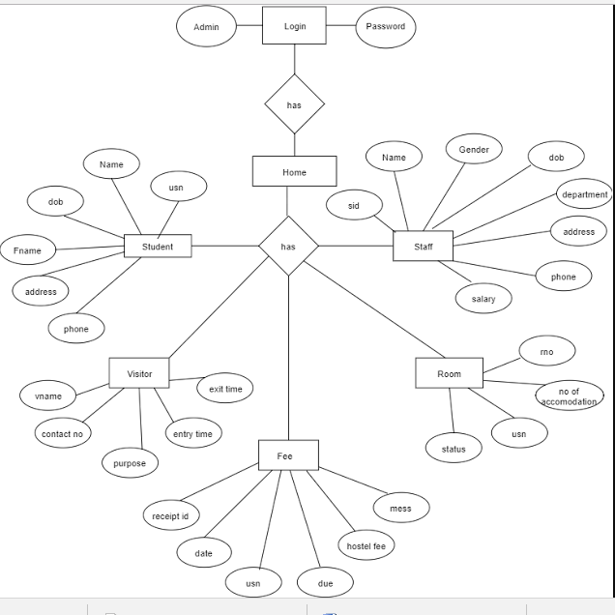

**Figure 3.1**: ER Diagram

.

**3.3 Schema Diagram**

Student

|  |  |  |  |  |  |  |
| --- | --- | --- | --- | --- | --- | --- |
| usn | name | Dob | Fname | Address | phone | rno |

Staff

|  |  |  |  |  |  |  |  |
| --- | --- | --- | --- | --- | --- | --- | --- |
| sid | Name | Gender | Dob | Dept | Address | Phone | salary |

Room

|  |  |  |  |
| --- | --- | --- | --- |
| usn | rno | Capacity | status |

Fee

|  |  |  |  |
| --- | --- | --- | --- |
| usn | Hostel_fee | Mess_fee | Balance_amt |

Visitor

|  |  |  |  |  |  |  |
| --- | --- | --- | --- | --- | --- | --- |
| usn | Vname | Phone | Address | Purpose | Login_in | Login_out |

Login

|  |  |
| --- | --- |
| Admin | password |

**Figure 3.2**: Schema Diagram

The schema diagram of a [database system](https://en.wikipedia.org/wiki/Database_system) is its structure described in a [formal language](https://en.wikipedia.org/wiki/Formal_language) supported by the [database management system](https://en.wikipedia.org/wiki/Database_management_system) (DBMS). The term "schema" refers to the organization of data as a blueprint of how the database is constructed. The formal definition of a [database](https://en.wikipedia.org/wiki/Database) schema is a set of formulas called [integrity constraints](https://en.wikipedia.org/wiki/Integrity_constraints) imposed on a database. These integrity constraints ensure compatibility between parts of the schema. All constraints are expressible in the same language. A database can be considered a structure in realization of the [database language](https://en.wikipedia.org/wiki/Database_language). The states of a created [conceptual schema](https://en.wikipedia.org/wiki/Conceptual_schema) are transformed into an [explicit mapping](https://en.wikipedia.org/wiki/Explicit_and_implicit_methods), the database schema. This describes how real-world entities are [modeled](https://en.wikipedia.org/wiki/Data_modeling) in the database.

The above Schema is defined for Hostel Management System. All the various table used are described in the following schema. The necessary Primary keys and the corresponding Foreign keys are also represented.

**3.4 Queries**

The below mentioned are all the queries used to perform various tasks in MySQL such as insert, delete, update. A short description of the query is also provided.

* **Query:** create table student(

usn number primary key,

name varchar2(15),

dob date,

fname varchar2(15),

address varchar2(30),

phone number

);

**Description:** This query is used to create a table called student which will store information of students.

* **Query:** create table staff(

sid number primary key,

name varchar2(15),

gender varchar2(1),

dob date,

dept varchar2(10),

address varchar2(30),

phone number,

salary number

);

**Description:** This query is used to create a table called staff which will store information of staff.

* **Query:** create table room(

usn number,

foreign key(usn) references student(usn),

capacity number,

room_no number,

status varchar2(10));

**Description:** This query is used to create a table called room which stores information of rooms capacity, status and students allocated in that particular room.

* **Query:**insert into student(usn, name, dob, fname, address, phone) values ('${usn}', '${name}', '${dob}', ‘${fname}’, '${address}', '${phone}');

**Description:** This query is used to insert into table student. Instead of values, variables are given which contain values given by user. All the values to be inserted are mentioned in a chronological order and are inserted into the table according to the order.

* **Query:** insert into staff(usn, name, gender, dob, dept, address, phone, salary) values( '${usn}', '${name}', '${gender}', '${dob}', '${dept}', '${address}', '${phone}', '${sal}');

**Description:** This query is used to insert into table staff. Instead of values, variables are given which contain values given by user. All the values to be inserted are mentioned in a chronological order and are inserted into the table according to the order.

**3.4.1 Stored Procedures**

* **Procedure:** create procedure homedata()

Begin

Select * from student;

Select * from staff;

Select * from fee;

Select * from room;

Select * from visitor;

End

**Description:** This Stored Procedure retrieves data from different tables to display on homepage.

**3.4.2 Triggers**

* DELIMITER //

CREATE TRIGGER checkSalary

before insert on staff for each row

if NEW.salary < 0 then set NEW<salary = 0;

end if

DELIMITER

**Chapter 4**

**Results and Discussions**

The web page is opened in web browser. We have put in few screen shots in here to show the working of the webpage.

1. **Login**

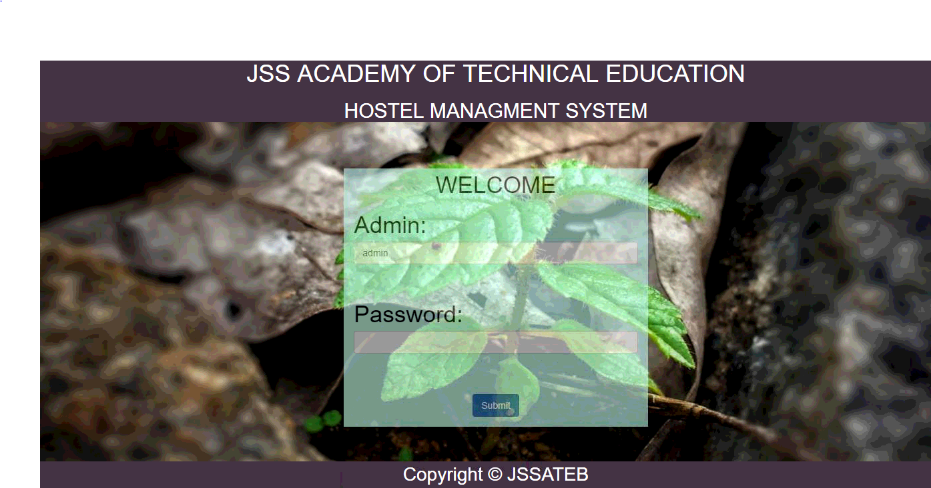

**Figure 4.1** Login Page

1. **Home**

This consists of the different pop-up menus showing the details of the different entities of hostel.

* It allows the different users to access the registration forms.
* He can view the Student, staff and other details
* Allot different students to the different rooms.
* Vacate the students for the hostels.
* Control the status of the fee payement.
* Edit the details of the students & modify the student records.

 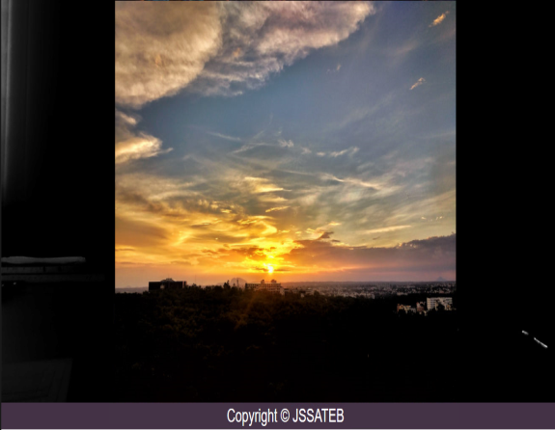

 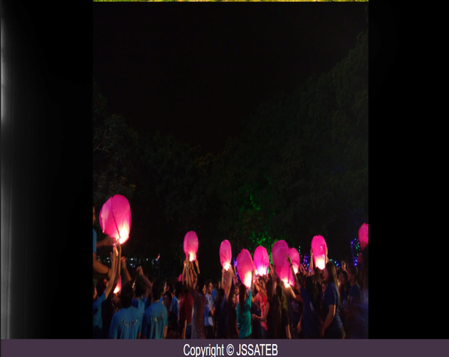

**Figure 4.2** Home Page

1. **Student**

This section provides an online form to the students which can be filled by them. This is later submitted to the Hostel authorities which can be verified by them before submit.

 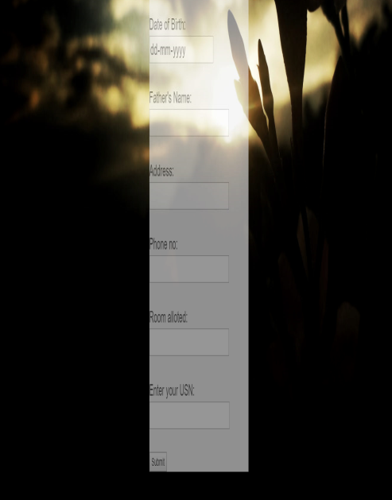

**Figure 4.3** Student Page

1. **Staff**

This section provides an online form to the staff which can be filled by them.

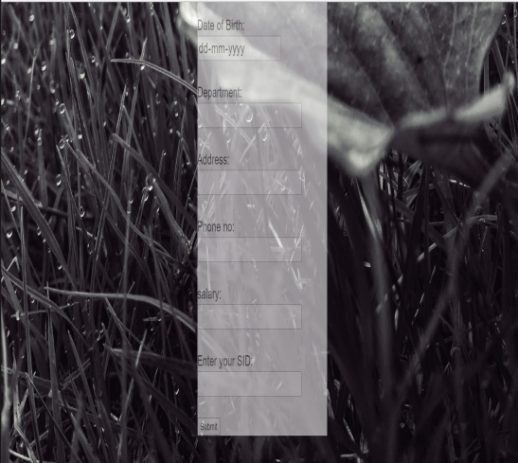

**Figure 4.4** Staff Page

1. **Mess**

This section contains mess details like Mess-menu and timings.

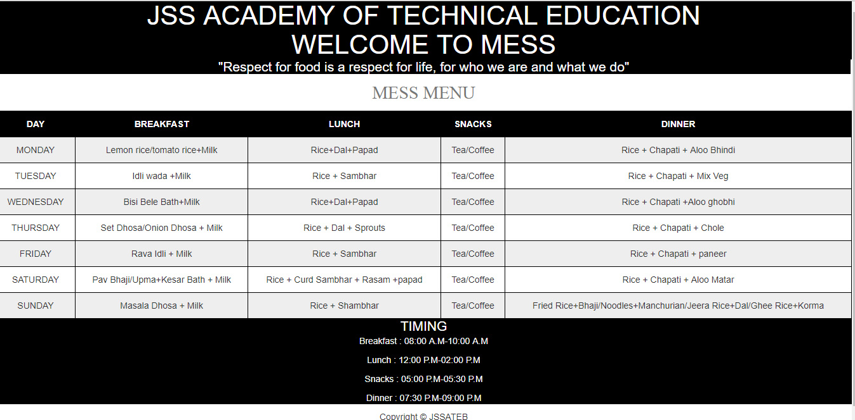

**Figure 4.5** Mess

1. **Room**

This section provides details about room capacity, status of room.

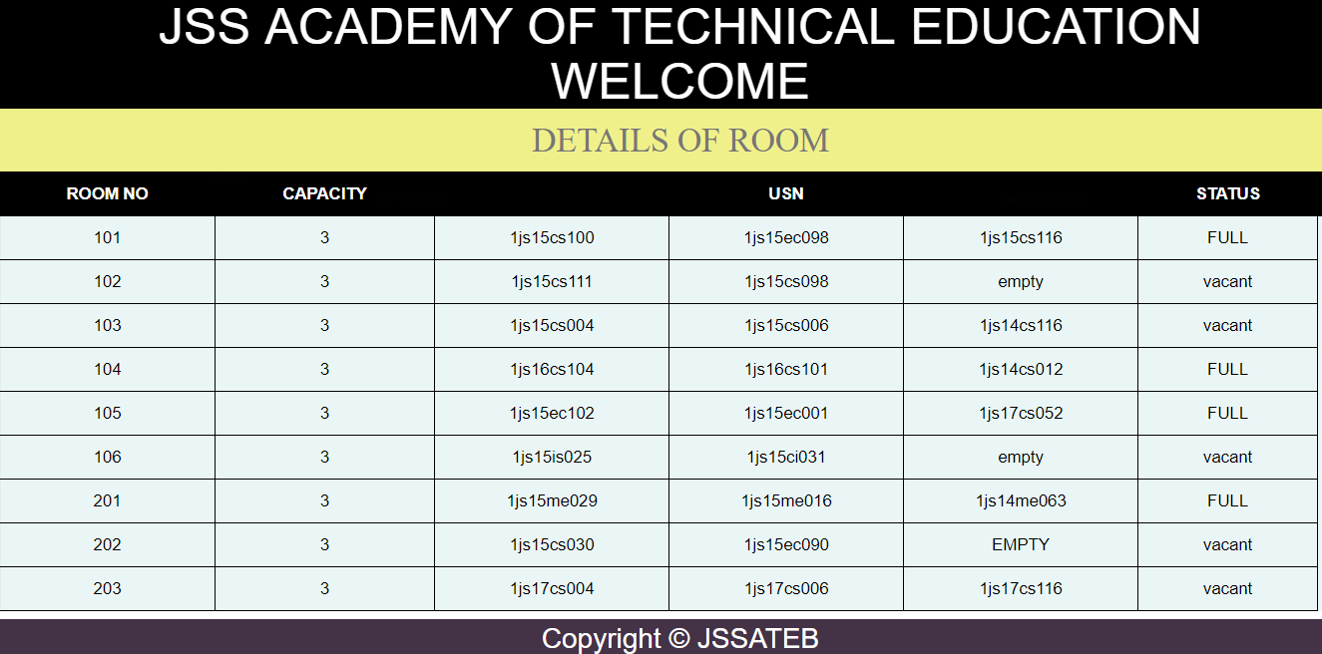

**Figure 4.6** Room

1. **Fee**

This section gives details about the students fee details.

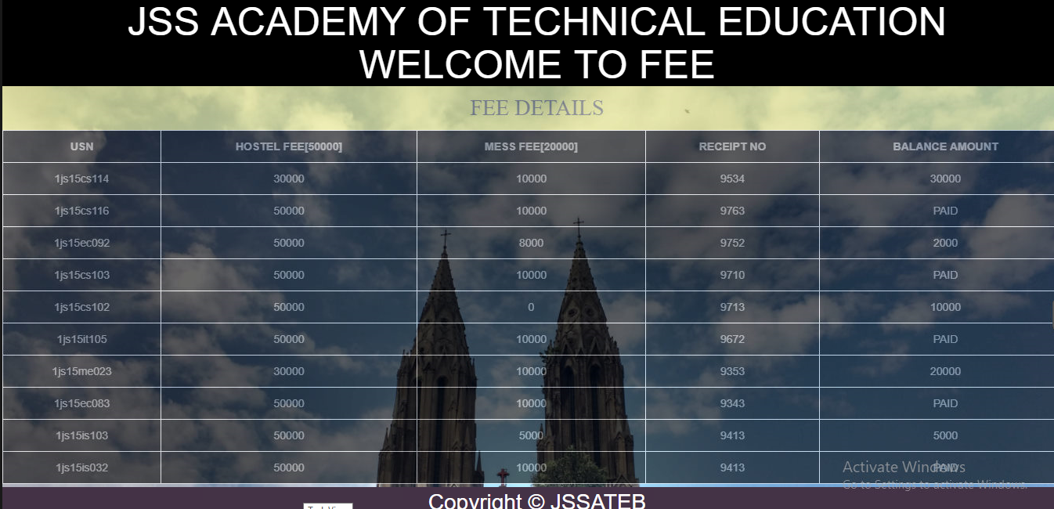

**Figure 4.7** Fee

1. **Visitor**

This stores information about the visitor and his details.

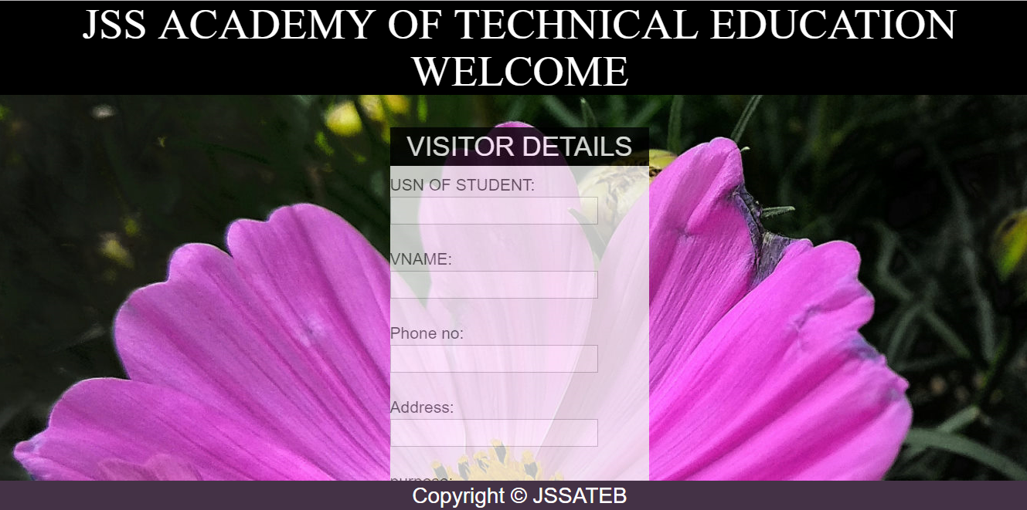

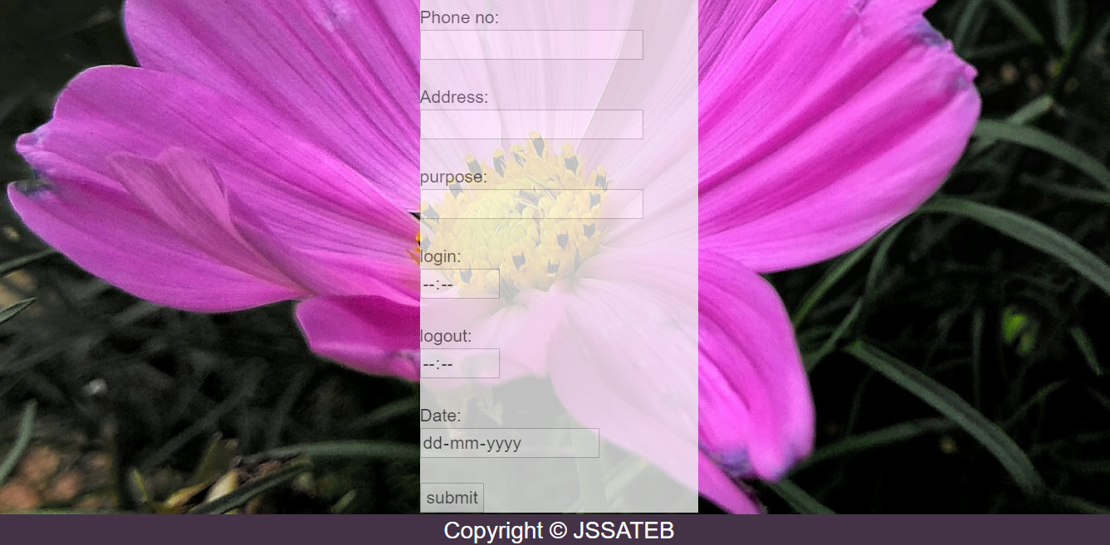

**Figure 4.8** Visitor Page

**Chapter 5**

**Conclusion and Future Enhancements**

5.1 **Conclusion**

The online hostel management system is web based software to provide colleges tudents accommodation to the institution hostel more efficiently. The existing system is manual based and needs lots of effort. This project keeps details of students staying in hostel as well as staff members of hostel. Since the allocation and other process are done manually, it consumes enough time. It may lead to mistakes in the allocation process as well as in the calculation of hostel and mess fee. For accommodating a large number of students into hostel this document is intended to minimize human works and make hostel allocation easier job for students and hostel authorities by providing online application for hostel, fee calculation, complaint registration, notice board etc. etc. Hostellers can view notice board, hostel fee, mess menu by login into the online system.

**5.2 Future Enhancements**

The future scope of our project is vast and can be used in extensive ways:

* It can be used as a real world application.
* It can be used to store information of students and staff in more precised manner.
* It can be designed to have more hostels of the same university.

**References**

[1] <https://stackoverflow.com>

[2] <https://www.npmjs.com/package/mysql>

[3] <https://www.w3schools.com>

[4] https://www.wikipedia.com